Name: Alveena Naz
Reg No. FA25-BSE-010
OOP LAB TASK 12

Activity 1:
import javax.swing.JFrame;
import javax.swing.JLabel;
import javax.swing.JTextField;
import java.awt.FlowLayout;

public class MYGUI extends JFrame {
MYGUI()
{
setLayout(new FlowLayout(FlowLayout.LEFT,10,20));
//componnets object creat
JLabel label1 = new JLabel("First Name");
JLabel label2 = new JLabel("MI");
JLabel label3 = new JLabel("Last Name");

JTextField text1 = new JTextField(8);
JTextField text2 = new JTextField(1);
JTextField text3 = new JTextField(8);
// add components
super.add(label1);
super.add(text1);
super.add(label2);
super.add(text2);
super.add(label3);
super.add(text3);
}

public static void main(String[] args) {
MYGUI frame = new MYGUI();
frame.setTitle("Show FlowLayout");
frame.setSize(500,500);
frame.setLocationRelativeTo(null);
frame.setDefaultCloseOperation(JFrame.EXIT_ON_CLOSE);
frame.setVisible(true);
}

}

OUTPUT

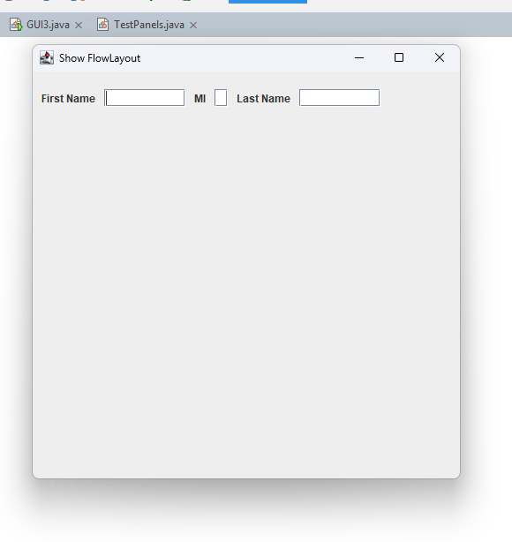

Activity 2:
import javax.swing.JFrame;
import javax.swing.JLabel;
import javax.swing.JTextField;
import java.awt.GridLayout;
public class GUI2 extends JFrame{
GUI2(){
setLayout(new GridLayout(3,2,2,3));
JLabel label1 = new JLabel("First Name");
JLabel label2 = new JLabel("MI");
JLabel label3 = new JLabel("Last Name");

JTextField text1 = new JTextField(8);
JTextField text2 = new JTextField(1);
JTextField text3 = new JTextField(8);
// add components
super.add(label1);
super.add(text1);
super.add(label2);
super.add(text2);
super.add(label3);
super.add(text3);
}
public static void main(String[] args) {
GUI2 frame = new GUI2();
frame.setTitle("Show GridLayout");
frame.setSize(500,500);
frame.setLocationRelativeTo(null);
frame.setDefaultCloseOperation(JFrame.EXIT_ON_CLOSE);
frame.setVisible(true);
}

}
OUTPUT:
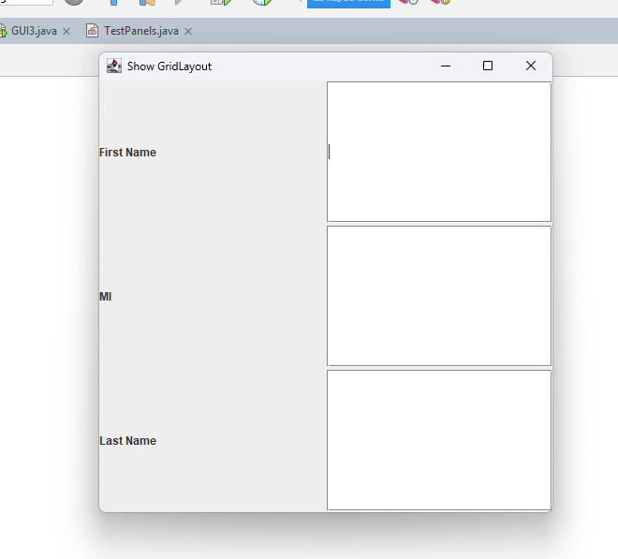

Activity 3:
import javax.swing.JFrame;
import javax.swing.JButton;
import javax.swing.JTextField;
import java.awt.BorderLayout;
public class GUI3 extends JFrame {
GUI3(){
setLayout(new BorderLayout(5,10));
JButton b1 = new JButton("East");
JButton b2 = new JButton("South");
JButton b3 = new JButton("West");
JButton b4 = new JButton("North");
JButton b5 = new JButton("Center");
// add components
super.add(b1,BorderLayout.EAST);
super.add(b2,BorderLayout.SOUTH);
super.add(b3,BorderLayout.WEST);
super.add(b4,BorderLayout.NORTH);
super.add(b5,BorderLayout.CENTER);

}
public static void main(String[] args) {
GUI3 frame = new GUI3();
frame.setTitle("Show BorderLayout");
frame.setSize(300,200);
frame.setLocationRelativeTo(null);
frame.setDefaultCloseOperation(JFrame.EXIT_ON_CLOSE);
frame.setVisible(true);
}

}
OUTPUT:
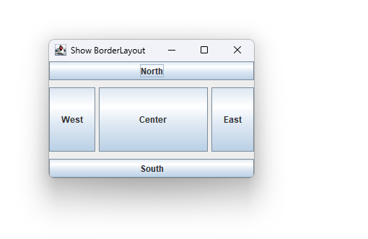

Activity 4:
import java.awt.*;
import javax.swing.*;

public class TestPanels extends JFrame {

TestPanels() {

JPanel p1 = new JPanel();
p1.setLayout(new GridLayout(4, 3));

// Add buttons 1 to 9
for (int i = 1; i <= 9; i++) {
p1.add(new JButton("" + i));
}

p1.add(new JButton("0"));
p1.add(new JButton("Start"));
p1.add(new JButton("Stop"));

JPanel p2 = new JPanel(new BorderLayout());

p2.add(new JTextField("Time to be displayed here"),BorderLayout.NORTH);
p2.add(p1, BorderLayout.CENTER);

add(p2, BorderLayout.EAST);

add(new JButton("Food to be placed here"), BorderLayout.CENTER);
}

public static void main(String[] args) {

TestPanels frame = new TestPanels();

frame.setTitle("The Front View of a Microwave Oven");
frame.setSize(400, 250);
frame.setLocationRelativeTo(null);
frame.setDefaultCloseOperation(JFrame.EXIT_ON_CLOSE);
frame.setVisible(true);
}
}

OUTPUT:
